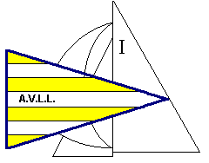
O’Bic EUROPEAN TEAM RACING CHAMPIONSHIP 2015
Lago di Ledro, ITALY
28th – 29th July 2015

Country A

NAME SURNAME DATE OF BIRTH GENDER

COACH
DECLARATION
The coach agree for the sailors to be bound to the OBCA and FIV rules, under which jurisdiction this regatta is sailed; to comply with the Regatta Instructions and to the class Rules, and he/she declare to undertake every responsibility on him/her for damages to the persons and to my own or third parties things, on water or ashore, in consequence of the participation in the regatta. In order to take part to the race the coach also declare that the sailors have all the physical requisites, as specified in the health certificate and the insurance to sail at her own risk taking upon myself all responsibility.
DATE SIGNATURE

